# PROJECT DEVELOPMENT PHASE

|  |  |
| --- | --- |
| **DATE** | **02 NOVEMBER 2022** |
| **TEAM ID** | **PNT2022TMID50137** |
| **PROJECT NAME** | **SMART FASHION RECOMMENDER APPLICATION** |

**INTEGRATING CHATBOT WITH HTML PAGE (SOURCE CODE)**

<script> Window.watsonAssisstantChatOptions

=

{

integrationID:

"614a4315-ff80-4187-

8fe4-2fd9b506b723", // The ID of this integration. region: "au- syd", // The region your integration is hosted in.

serviceInstanceID: "9670dcf8- 789f-4609-8d7a-6e25c412a9ec",

// The ID of your service instance. onLoad: function(instance) { instance.render(); }

};

setTimeout(function(){

const t=document.createElement('script'); t.src="https://web-

chat.global.assistant.watson.appdomain.cloud/versions/"+ (window.watsonAssistantChatOptions.clientVersion||'latest') + "/WatsonAssistantChatEntry.js";

document.head.appendChild(t);

});

</script>

# INTEGRATING CHATBOT WITH HTML PAGE:

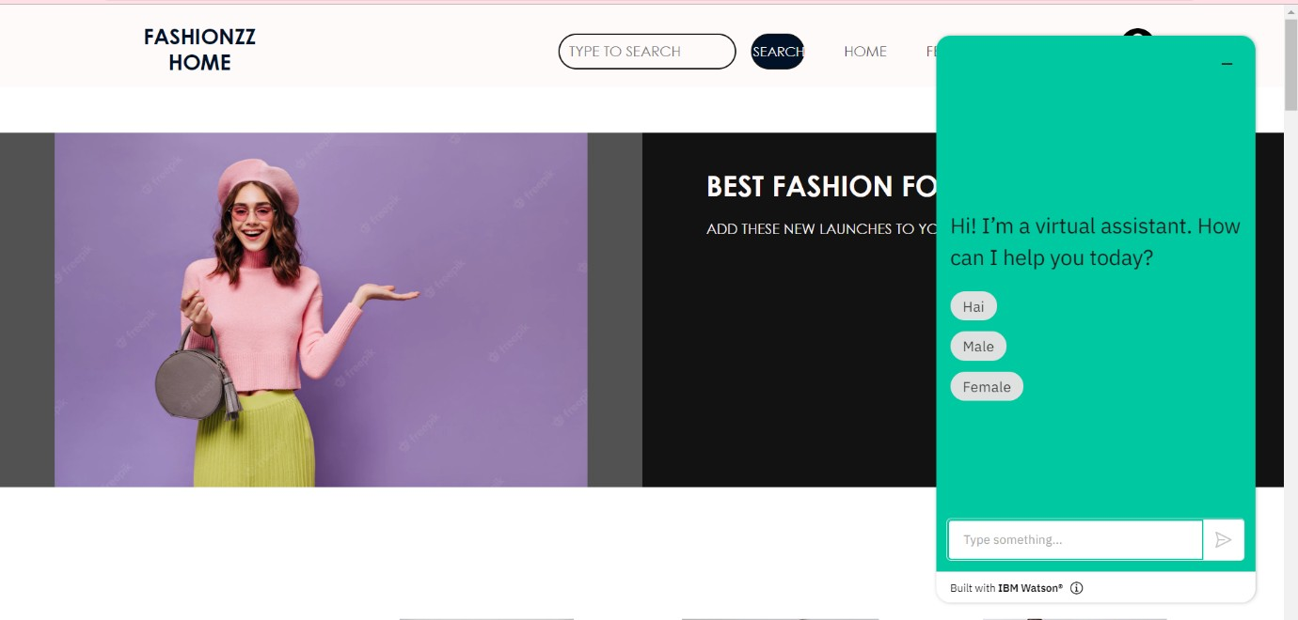

**DOCKER PUSH:**

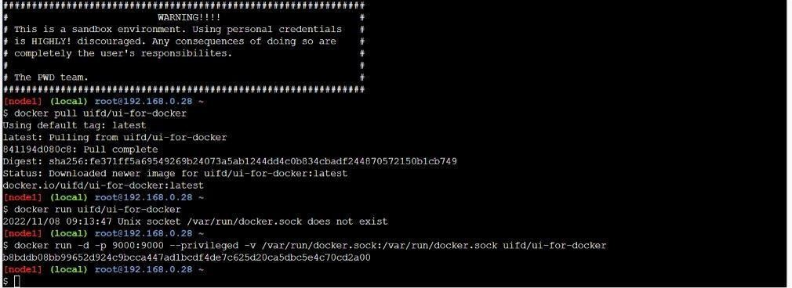

# CONTAINERIZING THE APPLICATION:

